BIOS 6611

Biostatistical Methods I

Self-assessment Homework #2

1. Use the information below on low birthweight babies. Answer the questions following. Be sure to show all of your work.

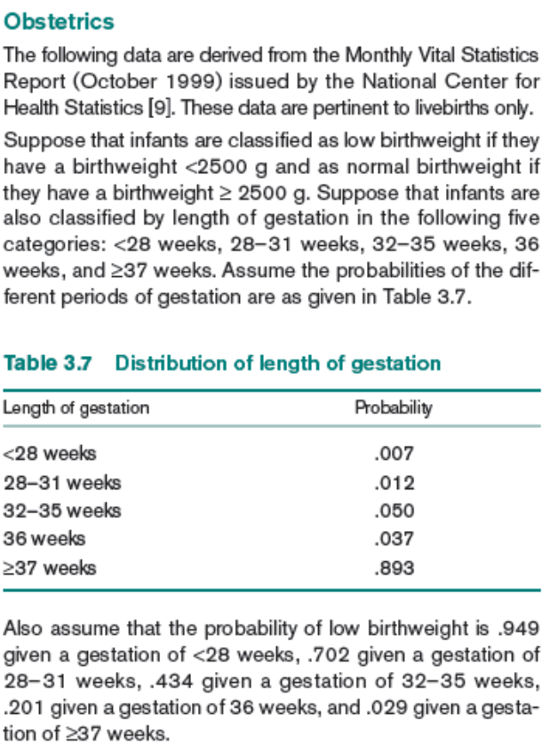

a. What is the probability that length of gestation is ≤ 36 weeks? Is this a joint, marginal or conditional probability?
b. What is the probability that a baby born at > 36 weeks has normal (not low) birthweight? Is this a joint, marginal or conditional probability?
c. What is the probability of having a low birthweight infant? Is this a joint, marginal or conditional probability?
d. What is the probability of having a baby that arrives earlier than 28 weeks and has low birthweight? Is this a joint, marginal or conditional probability?
e. Show that the events (length of gestation < 28 weeks) and (low birthweight) are not independent.
f. If it is known that a child had low birthweight, how likely is it (i.e., what is the probability) that the child was born before 28 weeks?
g. Construct the conditional probability distribution of gestational age conditional on being low birthweight. Verify that it is a probability distribution. If a child is known to have low birthweight, when was it most probably born?
- How does the conditional distribution of gestational age in (g) compare with the unconditional (marginal) distribution of gestational age in Table 3.7?
- Read the paper by Jessica Utts: “What Educated Citizens Should Know About Statistics and Probability”, particularly Sections 1, 2, and 8. Which conditional probability would be more informative in looking at differences in birthweight across levels of gestational age: P(GA=x| BW=y) or P(BW=y| GA=x)? Why?
- From the same source of data, it was also estimated that the probability that a low birthweight infant is female is 0.426. What is the estimate of the probability that an infant is low birthweight and female?
- From the same source of data, it is also estimated that the probability of infants being female is 0.48. What is the estimate of the probability that a normal birthweight infant is female?

2. Use the information given in Rosner 8th edition, pp. 66-67 (7th edition, pp. 61-62; 6th edition - pp. 69-70) concerning Genetics. Answer questions:
8th edition: 3.32-3.35, 3.37-3.42
7th edition: 3.30-3.33, 3.35-3.40
6th edition: 3.31-3.34, 3.36-3.41
Assume that offspring inherit the disease independently of each other. Show your work (include probability tree diagrams, if useful). Assume the family has one boy and one girl.

